TEACHER QUALITY
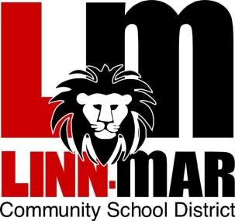
STUDENT ACHIEVEMENT

Professional Staff Development
Comprehensive School Improvement

2019-2020

Staff Development Days
August 20
October 7
November 4
January 20
March 30

TQSA Website is found on the district web site under “committees” & linked to the Intranet

Teacher Quality Student Achievement Committee
Debra Barry Kim Buelt Ryan Kreher
Carol O’Donnell Steven Starkey Mary Symmonds
Jeanne Turner Nathan Wear Erin Watts
Bob Read Shannon Bisgard ex-officio

Teacher Quality Student Achievement Committee Responsibilities

Senate file 277 (SF277), passed in 2007, requires each district and AEA to create a teacher quality committee with equal representation of administrators and teachers.
- The teacher members are appointed by the LMEA.
- The administrator members are appointed by the Superintendent.
- The Board of Education approves the committee.
The committee must function under the Iowa Open Meetings Law or Iowa Code Chapter 21. This includes conforming to the requirements regarding the timelines related to postings of meeting agendas, retention of official minutes and records.

The duties of the Teacher Quality Student Achievement Committee are as follows:

- Monitor the local implementation of the Student Achievement and Teacher Quality program.

- Following the Iowa Professional Development Model, determine the use and distribution of the professional development funds. As the legislative language states, “the use of the funds shall be balanced between the school district, attendance centers, and individual professional development plans.” Additional SF277 language also states, “The goal for the use of the funds is to provide one additional contract day or the equivalent thereof for professional development.”

All professional development plans, including district, attendance centers, and individual plans, must be aligned with the Iowa Professional Development Model (see page 4) including:
  - The career development of individual teachers is aligned with the Iowa Teaching Standards (see page 5)
  - Use of research-based instructional strategies is aligned with student needs and the district improvement goals
  - Evidence of instructional improvement components includes student achievement data, analysis, theory, classroom demonstration and practice, technology integration, observations, reflection, and peer coaching.

- Monitor the professional development in each attendance center to ensure that the professional development meets the school district, agency, attendance center, and individual professional development plans.

- Monitor the district teacher evaluation requirements to ensure they are “conducted in a fair and consistent manner throughout the school district or agency. In addition to any negotiated evaluation procedures, develop model evidence for the Iowa Teaching Standards and criteria.” The model evidence will minimize paperwork and focus on teacher improvement. The model evidence will determine which standards and criteria can be met with observation and which evidence meets multiple standards and criteria.

- Ensure the agreement negotiated pursuant to Chapter 20 determines the compensation for teachers on the committee for work responsibilities required beyond the normal work day.
After studying the data, analyzing the professional development needs at the individual, building, and district level, and carefully considering the options for ways funds may be used and distributed across the three levels, the Linn-Mar Teacher Quality Student Achievement Committee has determined the allocation and use of Professional Development funds.

A summary of this year’s plan is outlined below.

Total PD Allocation from State | $327,960
Individual PD Allocation  *per diem for PDD workshop | $223,207
Committee Members (teachers) | $5,000
Building Allocation | $120,131

The TQSA committee has developed criteria for Building Allocations/Expenditures based upon the Iowa Professional Development Model using the Plan, Do, Study, Act process.
- The PDSA criteria have been incorporated into application/reporting forms to be utilized for accountability of fund expenditures and effect on teaching and learning for the state report.
- The building leadership team will review the group or individual applications and will collaborate with the applicant(s) on the expectations for the activity or project.
- These forms, as well as samples for each level, can be found on the TQSA website linked from the district site (District – Committees – TQSA).

Learning opportunities that are the most likely to result in increased student learning should get priority when deciding what to fund. See the state parameters below.
PD most likely to get results Low likelihood PD
*Collective team effort *Single events with no sustained activities
*Focused on research-based instruction in a *No collaboration with peers to work on domain area extending the knowledge or skills
*Data collected on how often and how well *Book study groups – discussion without
teachers are using strategy demonstration or lesson planning
*Frequent and sustained over time *Make and take workshops
*Connects Pedagogy (way to teach) to
Content (what to teach) to Student
Based on previous years, here are successful LM uses of TQSA money:
- Interactive workshops rather than sit & listen conferences
- Teaching the trainers who then return to district & share this knowledge district-wide via workshop offerings
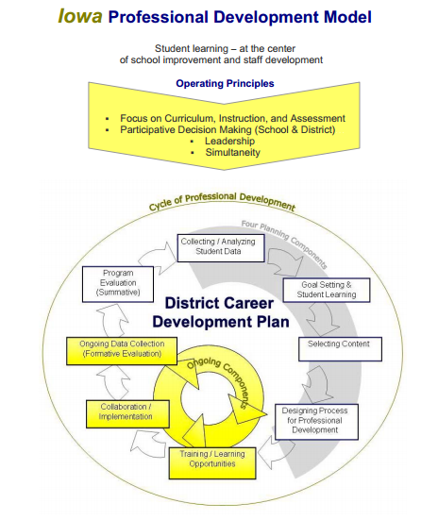
Iowa Teaching Standards and Criteria
Standard 1 Demonstrates ability to enhance academic performance and support for implementation of the school district’s student achievement goals.  a. Provides multiple forms of evidence of student learning and growth to students, families, and staff.  b. Implements strategies supporting student, building, and district goals.  c. Uses student performance data as a guide for decision making.  d. Accepts and demonstrates responsibility for creating a classroom culture that supports the learning of every student.  e. Creates an environment of mutual respect, rapport, and fairness.  f. Participates in and contributes to a school culture that focuses on improved student learning.  g. Communicates with students, families, colleagues, and communities effectively and accurately | Standard 2 Demonstrates competence in content knowledge appropriate to the teaching position.  a. Understands and uses key concepts, underlying themes, relationships, and different perspectives related to the content area.  b. Uses knowledge of student development to make learning experiences in the content area meaningful and accessible for every student.  c. Relates ideas and information within and across content areas.  d. Understands and uses instructional strategies that are appropriate to the content area.
Standard 3 Demonstrates competence in planning and preparing for instruction.  a. Uses student achievement data, local standards, and the district curriculum in planning for instruction. Iowa Department of Education 2  b. Sets and communicates high expectations for social, behavioral, and academic success of all students.  c. Uses student’s developmental needs, backgrounds, and interests in planning for instruction.  d. Selects strategies to engage all students in learning. e. Uses available resources, including technologies, in the development and sequencing of instruction | Standard 4 Uses strategies to deliver instruction that meets the multiple learning needs of students.  a. Aligns classroom instruction with local standards and district curriculum.  b. Uses research-based instructional strategies that address the full range of cognitive levels.  c. Demonstrates flexibility and responsiveness in adjusting instruction to meet student needs.  d. Engages students in varied experiences that meet diverse needs and promote social, emotional, and academic growth.  e. Connects students’ prior knowledge, life experiences, and interests in the instructional process.  f. Uses available resources, including technologies, in the delivery of instruction.
Standard 5 Uses a variety of methods to monitor student learning.  a. Aligns classroom assessment with instruction.  b. Communicates assessment criteria and standards to all students and parents.  c. Understands and uses the results of multiple assessments to guide planning and instruction.  d. Guides students in goal setting and assessing their own learning.  e. Provides substantive, timely, and constructive feedback to students and parents.  f. Works with other staff and building and district leadership in analysis of student progress. | Standard 6 Demonstrates competence in classroom management.  a. Creates a learning community that encourages positive social interaction, active engagement, and self-regulation for every student.  b. Establishes, communicates, models, and maintains standards of responsible student behavior.  c. Develops and implements classroom procedures and routines that support high expectations for student learning. Iowa Department of Education 3  d. Uses instructional time effectively to maximize student achievement.  e. Creates a safe and purposeful learning environment.
Standard 7 Engages in professional growth.  a. Demonstrates habits and skills of continuous inquiry and learning.  b. Works collaboratively to improve professional practice and student learning.  c. Applies research, knowledge, and skills from professional development opportunities to improve practice.  d. Establishes and implements professional development plans based upon the teacher’s needs aligned to the Iowa teaching standards and district/building student achievement goals.  e. Provides an analysis of student learning and growth based on teacher created tests and authentic measures as well as any standardized and district-wide tests | Standard 8 Fulfills professional responsibilities established by the school district.  a. Adheres to board policies, district procedures, and contractual obligations.  b. Demonstrates professional and ethical conduct as defined by state law and district policy.  c. Contributes to efforts to achieve district and building goals.  d. Demonstrates an understanding of and respect for all learners and staff.  e. Collaborates with students, families, colleagues, and communities to enhance student learning.

 | Iowa Professional Development Standards
1. | Professional development aligns with the Iowa Teaching Standards
2. | Professional development focuses on research-based instructional strategies aligned with the school district’s student achievement needs and the long-range and annual improvement goals established by the district.
3. | Professional development targets instructional improvement and is designed with the following components:  - Student achievement data and analysis  Theory  - Classroom demonstration and practice  - Observation and reflection  - Teacher collaboration  - Integration of instructional technology, if applicable
4. | Professional development includes an evaluation component that documents the improvement in instructional practice and the effect on student learning.
5. | Professional development supports the career development needs of individual teachers.
Category of Goals: |  | Professional Growth  System Goals  (Evaluation) | PLC Smart Goals | Building Improvement Plan Goals | District CSIP Goals
Who writes: |  | Teachers - can be done collaboratively  May or may not relate to  PLC smart goal | Teachers/ PLC Teams | Building  Administrators | Committee – as approved by district administrator
Report to: |  | Building Administrators | Building  Administrators | District  Administrators | Community;  administrators; teachers
Timelines:  When written  When reviewed |  | Page 29-30, 31, or 32 of  Professional Growth Handbook (for career teachers)  Goal could be multiple year | Drafted end of previous school year  Written beginning of the school year  (August)  Ongoing review with each PLC team meeting | Annually (August) | Updated annually
Impacting: |  | Individual teacher | Student learning (backed by data) | Teachers &  Students | Teachers & Students
Align with: |  | Iowa Teaching Standards  (Page 6 of Professional  Growth Handbook) | Student Success Strategic Plan  - Social emotional learning  - Standards  - Instructional strategies | Principals will align building goals with the three areas of student success portion of the strategic plan | K-6 Literacy

