August 2018 Newsletter
Novak Elementary
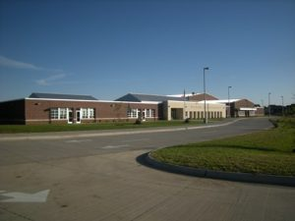

401 29th Avenue, Marion, IA 52302
https://www.linnmar.k12.ia.us/school/novak/
Ph: 319-447-3300
From the Principal
Dear Families,
What a great start to the 2018-2019 School Year! We are excited to welcome our returning families and anxious to get to know our new families.
Since we are about a week into the school year, many of you may have already attended parent meetings. For our early childhood families, you were able to meet your child’s teachers through a home visit. Hopefully, you have had the opportunity to sign up for Seesaw. All of our teachers use this tool to communicate with families. It’s a little bit like a protected Facebook for the classroom. Students and teachers post pictures and messages about classroom activities. Teachers can grant individual permissions for families to only see posts from their own children. You can learn more about Seesaw by watching this short video. Introduction to Seesaw
In addition to Seesaw, I invite you to follow Novak on Facebook and Twitter. Facebook is just Novak Elementary and Twitter is @Novakelem
A few changes to watch for this year include different state-required assessments and changes in the report card. For the past four years we have been taking a state reading test called FAST. This is for ECBP, kindergarten, and first through fifth grade. This year we are adding another part to the reading test, as well as a math test. Due to the addition of these state-required assessments, we are discontinuing some other exams, such as NWEA reading and math for second, third and fourth grade. Your child’s teacher will explain the assessment changes at conferences.
Last spring we let you know that Linn-Mar is moving from trimesters to quarters for grading purposes. This means that you will receive a report card for your child in January and May. We will still have conferences in October and February.
At the end of last year, the Building Leadership Team created our school mantra: Seek challenges, choose to grow. All staff promote a growth mindset with children. We believe that all children are capable of learning at high levels with hard work and persistence. When a child is heard to say, “I can’t do it.”, an adult responds with, “You can’t do it, YET.”
During the days leading up to the first day of school, the staff were busy getting ready to welcome all the children back to Novak. Our focus this year is “learn their story”. We believe that all children and adults have a story that makes them unique. Learning more about each other helps us to work together more effectively.
We look forward to getting to know each of your families better this year. Please contact me with any questions, concerns, or just good news.
Sincerely,
Carol O’Donnell
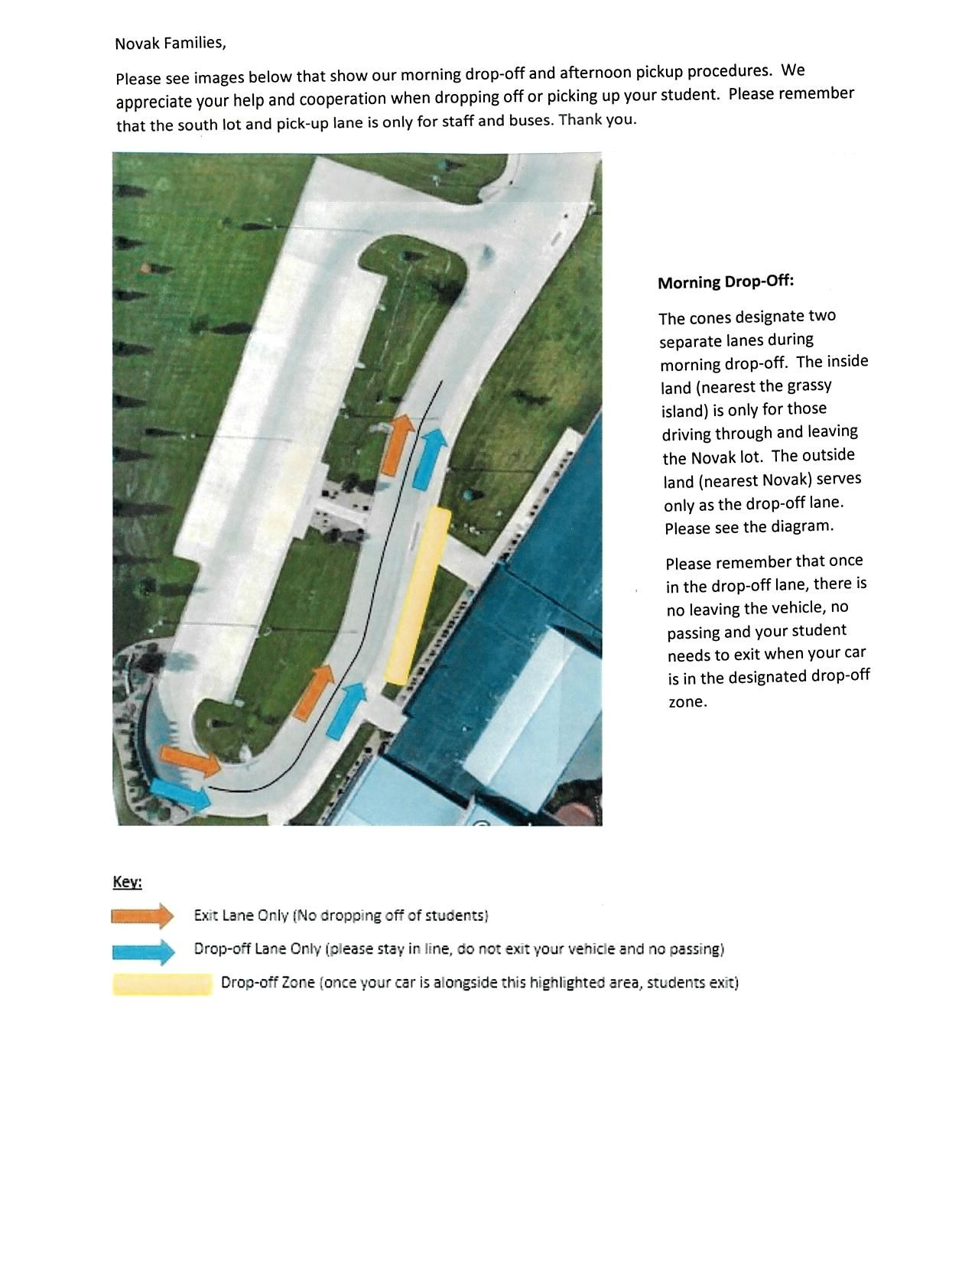
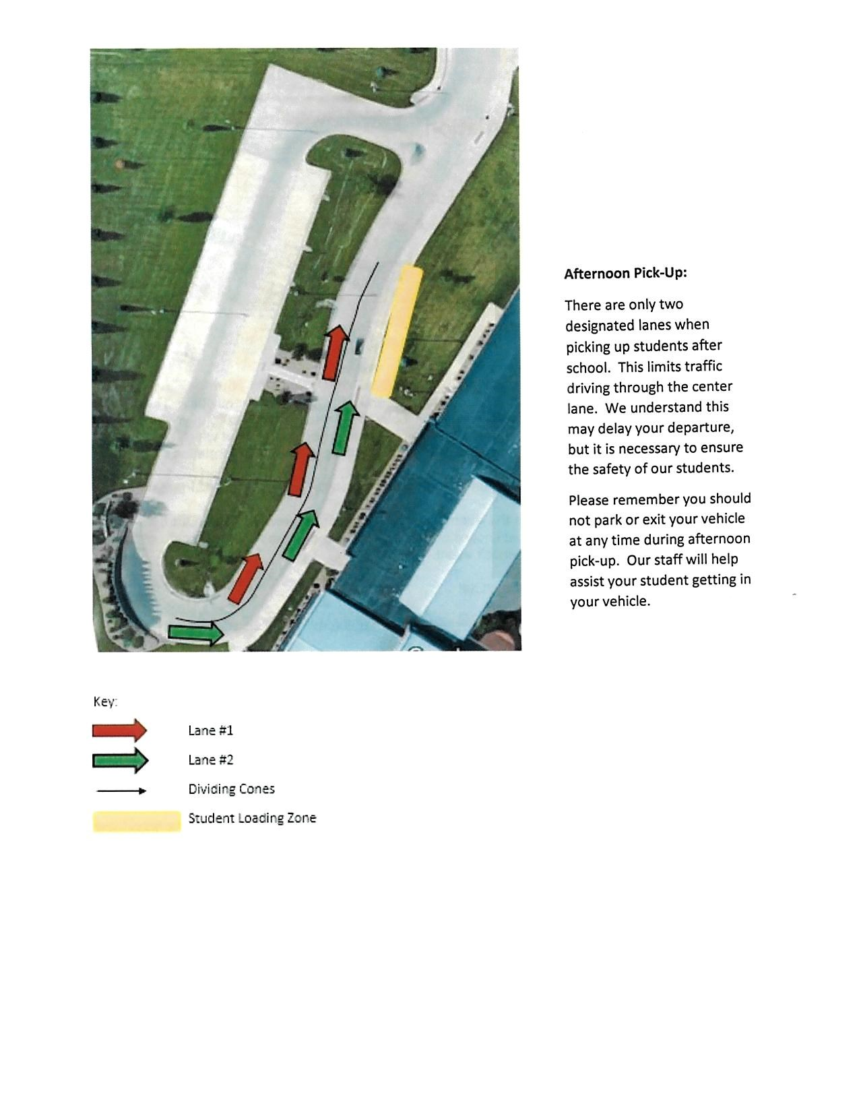
Calendar of Events
8/30 - 3rd Grade Parent Meeting 5:30 pm
8/30 - 5th Grade Parent Meeting 6:15 pm
9/3 - NO SCHOOL - Labor Day
9/5 - NO SCHOOL - ECBP/LL
9/6 - Volunteer Workshop 8-10 am
9/6 - 1st Grade Parent Meeting - 5:30 pm
9/6 - 4th Grade Parent Meeting - 6:15 pm
9/7 - School Pictures
9/11 - PTO Grandparents' Day 7:00 am
9/11 - PTO Meeting 6:30 pm
9/13 - Volunteer Workshop 8-10 am
9/13 - Volunteer Orientation 9:00 am
9/18 - Stride with Pride
9/18 - PTO Ice Cream Social
10/3 - NO SCHOOL ECBP/LL

Linn-Mar Emergency / Weather Alerts
To receive text alerts from Linn-Mar Community School District please go this link and sign up. You will receive alerts regarding emergencies, early outs, etc.
https://www.linnmar.k12.ia.us/district/cancellations-and-delays/
You may sign up for all district alerts or alerts for individual schools. Weather delays, early outs and cancellations are also on local t.v. and radio stations, as well as the Linn-Mar website.
Novak Social Media Links
We have several places we share information on social media. Please use these links to connect with Novak.
Facebook: https://www.facebook.com/Novak-Elementary-2035236950090900/
Twitter: https://twitter.com/novakelem?lang=en

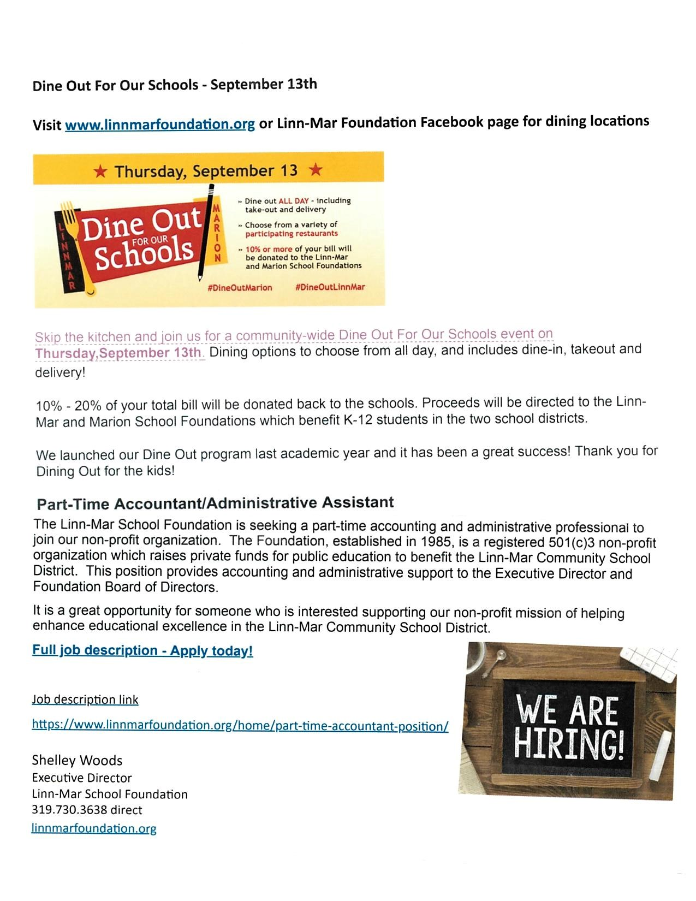
We are happy to have all of our Novak students and families back for another school year! Please contact us if you have any concerns or questions!
319-447-3300

