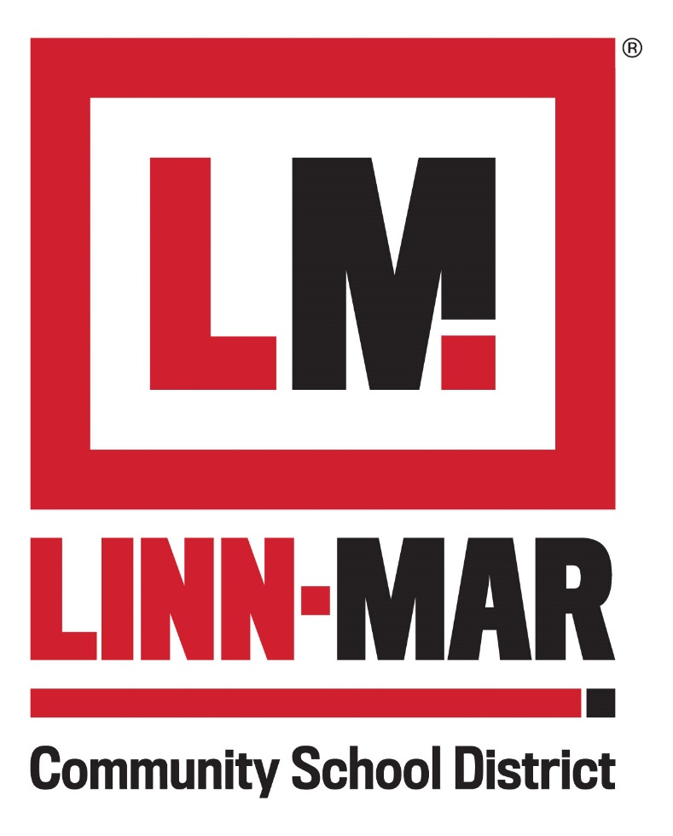
Recognition
& Awards Program

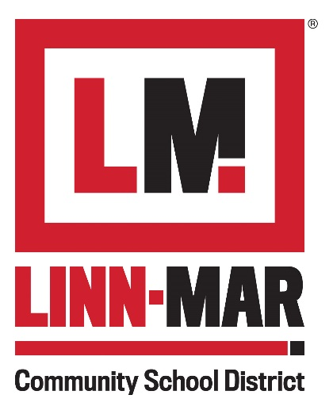

Recognition
& Awards Program
Linn-Mar Community School District’s Recognition and Awards Program serves to highlight the excellence that exists in all areas including service and job functions across the school district by rewarding the accomplishments and achievements of our staff, community partners, and colleagues. Linn-Mar chooses to recognize and reward work and behaviors that support/further the mission, goals, values and initiatives of the Linn-Mar Community School District. Nominees must have made a significant impact at LM as well as meet the respective criteria for selection.
Across the district, employees, community partners and colleagues may be nominated by anyone in the district, their respective school, department or community members. These nominees are then submitted to the Linn-Mar Employee Recognition Committee to determine the winners from each category (a maximum of two winners from each award category). All nominees are invited to attend Linn-Mar’s LIONS/Volunteer Recognition Open House where the award winners receive a plaque and recognition from the district.
Award winners are selected based on the criteria established for each category. The awards selection committee, comprised of a non-voting chairperson, an administrator, certified staff, non-certified staff, a Linn-Mar Foundation member, a Booster Club member, and community members, will evaluate each nomination. Committee terms are three years. District and community diversity is sought. Selection committee names will not be published. Please note that nominators and nominees are kept anonymous throughout the selection process.
A person can be nominated for an award in the following categories:
L – Living Legend Award for Excellence in Leadership
I – Innovator Award for Excellence in Positive Change
O – Optimizer Award for Excellence in Teamwork
N – Newcomer Award for Excellence in New Ideas
S – Service Award for Excellence in Superior Performance
Lion Pride Award – Going the Extra Mile
The Shirley Pantini Award
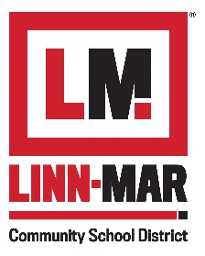
LIVING LEGEND AWARD FOR EXCELLENCE IN LEADERSHIP

Recognition & Awards Program
The Living Legend Award for Excellence in Leadership is granted to any employee, retiree, or board member of Linn-Mar Community School District who exemplifies the following qualities:
- Demonstrates the ability to lead and guide others within their organization with a spirit of cooperation and respectful treatment of others
- Facilitates the identification of strategic goals as well as inspires and organizes people to achieve a common goal
- Is consistently looked to for guidance and advice
- Displays and lives “lifelong learning”
- Motivates and engages others within the district and models leadership behavior
- Demonstrates an enthusiastic and genuine belief in the capacity of others
- Strengthens subordinates’ will and provides a means by which they can achieve
- Provides a clear vision with a focus on end goals and intellectual stimulation
- Remains positive and expresses optimism despite obstacles and setbacks
- Encourages initiative in others and creates conditions where subordinates can achieve their own successes
- Creates a climate of trust and collaboration
- Accepts responsibility and accountability in helping to advance the school district’s mission and goals
- Builds effective collaborative relationships across different groups or departments within the school district to define and solve problems or reach agreements on a course of action while considering multiple perspectives
The recipient of this award will foster cooperation, collaboration and open communication of the school district’s policies and procedures to better perform beyond the scope of his/her regular day-to-day job duties and responsibilities. The recipient must have collaborated with others and exhibited significant effort to advance the school district’s goals and mission statement. The recipient is an individual who seeks ways to make things better and change the work environment.
Frequency of Award
- Annually
- This award will only be granted if there are qualified nominations
Criteria for Selection
- Must be an employee or board member associated with the Linn-Mar Community School District
- Retired employees and Administrators are eligible for this award
- Members of the school district community may nominate individuals for this award; self-nominations are ineligible
- Previous recipients of the Living Legend Award for Excellence in Leadership are not eligible to receive any Living Legend Award for Excellence in Leadership for two years (24 months) after the initial award date
- This award will only be granted when there are qualified nominations
Award to Recipient
- Plaque or other item
- Recognition open house
- Recognition on the Linn-Mar Community School District website
Nomination Process
- Nominator completes the Living Legend Award for Excellence in Leadership Form and facilitates completion of the nomination process
- Completed nomination form and a cover letter (not to exceed one page) written by the nominator are submitted to the Linn-Mar Community School District Employee Recognition Committee/Human Resources by 4 p.m. on March 13, 2020. Questions may be directed to Casey Fasselius at 447-3009 or cfasselius@linnmar.k12.ia.us

INNOVATOR AWARD FOR EXCELLENCE IN POSITIVE CHANGE
PO
Recognition & Awards Program
The Innovator Award for Excellence in Positive Change is granted to any employee, retiree, LM board member, community partner, and colleague of Linn-Mar Community School District who exemplifies the following qualities:
- Creates positive change for and within the LM community
- Assumes a significant role in the development, implementation, and/or ongoing effectiveness of collaborative and positive organizational change that markedly increases the efficiency and effectiveness of the team/department/district and serves as a role model for others within the district
- Builds effective and positive collaborative relationships with different groups or departments within the school district to define and solve problems or reach agreements on a course of action while considering multiple perspectives
- Introduces innovations that not only address a need and solve a problem but also seize an opportunity and create an optimal learning and working environment
  - Innovation satisfies an existing need or desire; is unique/different and has distinct, revolutionary advantages over current practice and/or any alternatives.
  - Innovation is communicated in clear and compelling ways. Clearly engages the team/department/district – delivered and made available to the entire district (if applicable).
  - Innovation has immediate and longer-term positive impact on the LM community and an inspiration to future innovators
  - Innovation looks to eliminate inefficiencies
- Demonstrates a spirit of teamwork, cooperation and respectful treatment of others
- Works to meet school district objectives by assisting peers or subordinates, sharing knowledge and stimulating collaboration and a positive work environment for accomplishing tasks
- Accepts responsibility and accountability in helping to advance the school district’s mission and goals
The recipient of this award fosters cooperation, collaboration and open communication of the school district’s policies and procedures to better perform beyond the scope of his/her regular day-to-day responsibilities. The recipient must have collaborated with others and exhibited significant efforts to advance the school district’s goals and mission statement. The recipient is an individual who seeks ways to make things better to positively impact LM students, staff and community.
Frequency of Award
- Annually
- This award will only be granted if there are qualified nominations
Criteria for Selection
- Must be an employee, community partner, and/or colleague associated with the Linn-Mar Community School District
- Retired employees and Administrators are eligible for this award
- Members of the school district community may nominate individuals for this award; self-nominations are ineligible
- Previous recipients of the Innovator Award for Excellence in Positive Change are not eligible to receive any Innovator Award for Excellence in Positive Change for two years (24 months) after the initial award date
- This award will only be granted when there are qualified nominations
Award to Recipient
- Plaque or other item
- Recognition open house
- Recognition on the Linn-Mar Community School District website
Nomination Process
- Nominator completes the Innovator Award for Excellence in Positive Change Form and facilitates completion of the nomination process
- Completed nomination form and a cover letter (not to exceed one page) written by the nominator are submitted to the Linn-Mar Community School District Employee Recognition Committee/Human Resources by 4 p.m. on March 13, 2020. Questions may be directed to Casey Fasselius at (319) 447-3009 or cfasselius@linnmar.k12.ia.us

OPTIMIZER AWARD FOR EXCELLENCE IN TEAMWORK

Recognition & Awards Program
The Optimizer Award for Excellence in Teamwork is granted to any employee, retiree, LM board member, community partner, and colleague of Linn-Mar Community School District who exemplifies the following qualities:
- Demonstrates a spirit of teamwork, cooperation and respectful treatment of others
- Takes a leadership role in the team to meet school district objectives by assisting peers or subordinates, sharing knowledge and stimulating collaboration and a positive work environment for accomplishing tasks
- Reinforces positive and productive behaviors in others
- Demonstrates a “we” vs. “I” approach and works to meet school district objectives by assisting peers or subordinates, sharing knowledge, stimulating collaboration and a positive work environment for accomplishing tasks while giving credit to “we” vs. “me”
- Takes responsibility for team commitments and motivates and encourages others to assist team mates that may be struggling
- Recognizes others’ strengths on the team and strives to utilize and maximize each person’s unique talents to achieve goals
- Embraces diversity in thinking and seeks out others’ perspectives
- Connects team members and seeks out and utilizes resources to enhance team performance
- Accepts responsibility and accountability in helping to advance the school district’s mission and goals
- Builds effective collaborative relationships with different groups or departments within the school district to define and solve problems or reach agreements on a course of action while considering multiple perspectives
The recipient of this award fosters cooperation, collaboration and open communication of the school district’s policies and procedures to better perform beyond the scope of his/her regular day-to-day job duties and responsibilities. The recipient must have collaborated with others and exhibited significant efforts to advance the school district’s goals and mission statement. The recipient is an individual who seeks ways to make things better to positively impact LM students, staff and community.
Frequency of Award
- Annually
- This award will only be granted if there are qualified nominations
Criteria for Selection
- Must be an employee, community partner, and/or colleague associated with the Linn-Mar Community School District
- Retired employees and Administrators are eligible for this award
- Members of the school district community may nominate individuals for this award; self-nominations are ineligible
- Previous recipients of the Optimizer Award for Excellence in Teamwork are not eligible to receive any Optimizer Award for Excellence in Teamwork for two years (24 months) after the initial award date
- This award will only be granted when there are qualified nominations
Award to Recipient
- Plaque or other item
- Recognition open house
- Recognition on the Linn-Mar Community School District website
Nomination Process
- Nominator completes the Optimizer Award for Excellence in Teamwork Form and facilitates completion of the nomination process
- Completed nomination form and a cover letter (not to exceed one page) written by the nominator are submitted to the Linn-Mar Community School District Employee Recognition Committee/Human Resources by 4 p.m. on March 13, 2020. Questions may be directed to Casey Fasselius at (319) 447-3009 or cfasselius@linnmar.k12.ia.us

NEWCOMER AWARD FOR EXCELLENCE IN NEW IDEAS
Recognition & Awards Program
The Newcomer Award for Excellence in New Ideas is granted to any employee or LM board member of Linn-Mar Community School District with a maximum of five years of service who exemplifies the following qualities:
- Provides outstanding positive contributions to the overall mission, objectives and goals of the district. Contributions may be in the form of service to the students, staff, parents or LM community
- Achieves clear accomplishments that have a positive impact on the entire team, school, department or district
- Develops and implements an innovative process or procedure that directly impacts the school district community in a positive manner
- Receives constructive criticism with an open mind and uses it to “improve” both personally and professionally
- Honors the “old” way of doing things while igniting a “new” process or strategy to improve LM
- Pushes through adversity and perseveres
- Ability to present/sell a new and unique idea/strategy that “breaks the mold” and makes a positive contribution to LM
- Works to meet school district objectives by assisting peers or subordinates, sharing knowledge and stimulating collaboration and a positive work environment for accomplishing tasks
- Accepts responsibility and accountability in helping to advance the school district’s mission and goals
The recipient of this award has demonstrated the true spirit of Linn-Mar Pride on and off the job with passion and enthusiasm. The recipient must have made a unique contribution of embracing the school district spirit and has demonstrated examples of high-quality service, and a track record of building relationships that lead to continuous improvement. The recipient must have exhibited significant efforts to advance the school district goals and mission.
Frequency of Award
- Annually
- This award will only be granted if there are qualified nominations
Criteria for Selection
- Must be a LM employee or board member
- Must be an employee or board member for a maximum of 5 years
- Members of the school district community may nominate individuals for this award; self-nominations are ineligible
- Previous recipients of the Newcomer Award for Excellence in New Ideas are not eligible to receive another Newcomer Award for Excellence in New Ideas for two years (24 months) after the initial award date
- This award will only be granted when there are qualified nominations
Award to Recipient
- Plaque or other item
- Recognition open house
- Recognition on the Linn-Mar Community School District website
Nomination Process
- Nominator completes the Newcomer Award for Excellence in New Ideas Form and facilitates completion of the nomination process
- Completed nomination form and a cover letter (not to exceed one page) written by the nominator are submitted to the Linn-Mar Community School District Employee Recognition Committee/Human Resources by 4 p.m. on March 13, 2020. Questions may be directed to Casey Fasselius at (319) 447-3009 or cfasselius@linnmar.k12.ia.us

SERVICE AWARD FOR EXCELLENCE IN PERFORMANCE

Recognition & Awards Program
The Service Award for Excellence in Performance is granted to any employee of the Linn-Mar Community School District with a minimum of twenty years of service who exemplifies the following qualities:
- Consistently displays creativity and innovation, positive attitude, enthusiasm, productivity, flexibility and leadership
- Quality of work consistently exceeds expectations
- Leads by example
- Provides innovative ideas and follows through with implementation
- Effectively communicates positively with students, staff and the LM community
- Exceeds district expectations by consistently showing exceptional initiative in “going above and beyond” the defined duties of the job to provide service to students, staff and the LM community with timely and appropriate follow-up
- Effectively and positively resolves conflict (both with self and others)
- Consistently executes and/or accomplishes work early or by deadline
- Inspires excellence and dedication in others
- Consistently engages in LM activities both within and outside of their job responsibilities
- Provides significant and lasting contributions to their profession and the LM community
- Visibly supports the mission and vision of the school district
The recipient of this award has a strong knowledge and understanding of the school district’s policies and procedures and significantly and consistently exceeds performance expectations and the quality of work is overall exceptional. Employees who are considered for this Award should be evaluated on their performance based on creativity and innovation, positive attitude, enthusiasm, productivity, flexibility, leadership and work performance.
Frequency of Award
- Annually
- This award will only be granted if there are qualified nominations
Criteria for Selection
- Must be a LM employee or board member
- Must be an employee for a minimum of 20 years
- Members of the school district community may nominate individuals for this award; self-nominations are ineligible
- Previous recipients of the Service Award for Excellence in Performance are not eligible to receive any Service Award for Excellence in Performance for two years (24 months) after the initial award date
- This award will only be granted when there are qualified nominations
Award to Recipient
- Plaque or other item
- Recognition open house
- Recognition on the Linn-Mar Community School District website
Nomination Process
- Nominator completes the Service Award for Excellence in Performance Form and facilitates completion of the nomination process
- Completed nomination form and a cover letter (not to exceed one page) written by the nominator are submitted to the Linn-Mar Community School District Employee Recognition Committee/Human Resources by 4 p.m. on March 13, 2020. Questions may be directed to Casey Fasselius at (319) 447-3009 or cfasselius@linnmar.k12.ia.us

LION PRIDE AWARD – GOING THE EXTRA MILE

Recognition & Awards Program
The Lion Pride Award - Going the Extra Mile is granted to any employee, retiree, LM board member, community partner, and colleague of Linn-Mar Community School District who exemplifies the following qualities:
- Lives and exemplifies LM Lion PRIDE (“bleeds” LM red and black)
- Makes extraordinary contributions to the Linn-Mar Community School District
- Goes above and beyond daily expectations
- Displays a passion and commitment to ensure a world class environment for LM staff, students and the community
- Values and continually strives for self-improvement
- Demonstrates enthusiasm and high self-esteem in the quality of output
- Engages in innovative thinking and projects to positively affect LM
- Willingness to make commitments and keep promises in pursuit of team goals
- Demonstrates an ability to consistently make a significant positive impact beyond the school district, and within the larger community
- Expressions of pride through volunteering for special projects and events
- Demonstrates a positive attitude, and consistent dedication to the school district and others with whom they interact
The recipient of this award has demonstrated the true spirit of Linn-Mar Pride with passion and enthusiasm. The recipient must have made a unique contribution of embracing the school district spirit, demonstrating examples of high-quality service, and a proven track record of building relationships that lead to continuous improvement at LM. This award is to recognize a person that consistently goes above and beyond the call of duty, to shape the future for others and the school district.
Frequency of Award
- Annually
- This award will only be granted if there are qualified nominations
Criteria for Selection
- Must be an employee, board member, community partner, and/or colleague associated with the Linn-Mar Community School District
- Retirees and Administrators are eligible for this award
- Members of the school district community may nominate individuals for this award; self-nominations are ineligible
- Previous recipients of the Lion Pride Award - Going the Extra Mile are not eligible to receive another Lion Pride Award - Going the Extra Mile for two years (24 months) after the initial award date
- This award will only be granted when there are qualified nominations
Award to Recipient
- Plaque or other item
- Recognition open house
- Recognition on the Linn-Mar Community School District website
Nomination Process
- Nominator completes the Lion Pride Award - Going the Extra Mile Form and facilitates completion of the nomination process
- Completed nomination form and a cover letter (not to exceed one page) written by the nominator are submitted to the Linn-Mar Community School District Employee Recognition Committee/Human Resources by 4 p.m. on March 13, 2020. Questions may be directed to Casey Fasselius at (319) 447-3009 or cfasselius@linnmar.k12.ia.us

THE SHIRLEY PANTINI AWARD

Recognition & Awards Program
The Shirley Pantini Award - The Shirley Pantini Award is granted to any employee, retiree, LM board member, community partner, and colleague of Linn-Mar Community School District in honor of the equity and diversity work of Shirley Pantini, the district's first Equity Coordinator.
Frequency of Award
- Annually
- This award will only be granted if there are qualified nominations
Criteria for Selection
- Must be an employee, board member, community partner, and/or colleague associated with the Linn-Mar Community School District
- Retirees and Administrators are eligible for this award
- Members of the school district community may nominate individuals or groups for this award; self-nominations are ineligible
- Previous recipients of the Shirley Pantini Award are not eligible to receive this award a second time.
- This award will only be granted when there are qualified nominations
Award to Recipient
- Plaque or other item
- Recognition open house
- Recognition on the Linn-Mar Community School District website
Nomination Process
- Completed nomination form and a cover letter (not to exceed one page) written by the nominator are submitted to the Linn-Mar Community School District Employee Recognition Committee/Human Resources by 4 p.m. on March 13, 2020. Questions may be directed to Casey Fasselius at (319) 447-3009 or cfasselius@linnmar.k12.ia.us

Nomination Form Instructions

Recognition & Awards Program
Please use only this form to nominate an employee for the Recognition and Awards program.
All information must be TYPED or PRINTED (legibly)
Please review the criteria for eligibility (listed below) and the respective categories for each award before proceeding.

ELIGIBILITY
- Permanent employee, retiree, board member, community partner, or colleague.
- Anyone in the school district community may nominate individuals for this award; self-nominations are ineligible.
- Previous recipients of each Award of Excellence are not eligible to receive award for two years after the initial award date.

GUIDELINES
- All employees are eligible to nominate individuals during the announced period.
- Do not leave any columns blank.
- Nominator submits the completed nomination form and a one-page cover letter to Casey Fasselius at the LRC, in a sealed envelope on or before the due date.
- Nominations are screened for eligibility by the selection team constituted by the committee for this purpose. All decisions are final.
- The nominations will be kept confidential.
- Nominations and attachments become the property of the committee.

CATEGORIES
L – Living Legend Award for Excellence in Leadership
I – Innovator Award for Excellence in Positive Change
O – Optimizer Award for Excellence in Teamwork
N – Newcomer Award for Excellence in New Ideas
S – Service Award for Excellence in Superior Performance
Lion Pride Award – Going the Extra Mile
The Shirley Pantini Award
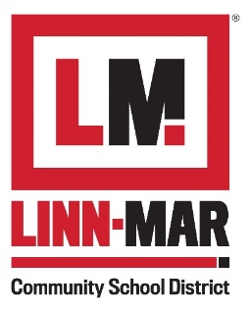
Recognition & Awards Program

LIONS Awards Nomination Form

Name of Nominee: ______________________________________________________________
Nominee’s Department/Affiliation with LM:__________________________________________
Nominee’s Contact Information (email and phone number):_____________________________
Nominator’s Name:______________________________________________________________
Nominator’s Department/Affiliation with LM:_________________________________________
Nominator’s Contact Information (email and phone number):____________________________

Please select from the following categories:
- L - Living Legend Award for Excellence in Leadership
- I - Innovator for Excellence in Positive Change
- O – Optimizer for Excellence in Teamwork
- N – Newcomer for Excellence in New Ideas
- S – Service for Excellence in Superior Performance
- Lion Pride Award – Going the Extra Mile
- Shirley Pantini Award

Please attach the following to this nomination form:
- A cover letter with a brief summary describing why your nominee should receive an award.
- Up to three letters of recommendation must be attached.
- Documentation should include description of the nominee’s accomplishments and qualifications.

All awards will not necessarily be given out each year. This will be at the discretion of the committee based on nominations submitted. Nominators will be notified by phone as to the selection of their nominee. Only those persons selected as recipients of the LIONS award will be notified.

Nominations are due to the Linn-Mar Community School District Employee Recognition Committee/Human Resources by Friday, March 13, 2020. Questions may be directed to: Casey Fasselius at (319) 447-3009 or cfasselius@linnmar.k12.ia.us
How to Write a Quality Award Nomination
The key to a well-written nomination is providing evaluators with specific information illustrating how the individual’s or group’s achievements have made a positive impact on Linn-Mar’s goals. The number of examples is not as important as ensuring that the nominee’s (or nominees’) contributions match the specific award criteria, and that there are measurable results. Here are some additional tips:
- Keep it brief. Write short sentences that are concise and give specific detail. Avoid giving work history or job descriptions, unless it directly relates to the award criteria. The goal is quality, not quantity.

- Answer the “what” and “how”.
  - What did the nominee(s) do?
    - Projects and/or activities above and beyond job descriptions
    - Any challenges or issues encountered and overcome
  - How did the nominee(s) do it?
    - Initiative and/or leadership
    - Teamwork
    - Creativity and/or innovation
    - Behaviors and/or attitudes
  - What were the results and/or impacts?
    - What did the nominee(s) accomplish?
    - Are there specific benefits derived from those efforts?

- Be clear and specific. Don’t assume the Rewards and Recognition selection committee members will understand the specific nature of a project or achievement without full explanations. Be specific about what the nominee(s) did and how that helps fulfill the school district’s mission.

- Say it like it is. Don’t worry about using “fancy” speech. Feel free to use bulleted lists when appropriate. Be sure to explain the technical details in such a way that non-experts will understand, and spell out/define any unfamiliar acronyms.

- Use concrete examples. Anecdotes, quotations from colleagues or students, specific numbers or statistics, etc. help strengthen your nomination. Describe the amount of time and resources spent on the project. If the project the nominee(s) is/are working on is still being developed or has not produced results, consider identifying major milestones completed. If this progress is not of substantial impact, consider waiting to submit the nomination until after the results/impact can be documented and supported.

- Communicate sincerity and personal commitment. Show that you personally value the contributions of your nominee(s).

- Consider a collaborative, group-written nomination. If you find yourself shying away from a solo nomination, then round up a colleague or two and write one together. This approach may make gathering ideas and writing the nomination easier.

- Review your nomination. Verify the accuracy of all information in the nomination.

- Ask questions. If you are unclear about the award criteria, ask for clarification.

The Human Resources Department is able to answer your questions. Please contact Casey Fasselius, cfasselius@linnmar.k12.ia.us or (319) 447-3009 for more information. Applications are due to the Linn-Mar Community School District Employee Recognition Committee/Human Resources no later than 4 p.m. on Friday, March 13, 2020.

